**Assessment 23– Jenkins-2**

**Trainee Name : Gargi Sharma**

**Mentor Name : Mr. Akansh Gupta**

**College Name : UPES**

1. **Create a jenkins pipeline Job to delete redundant docker images daily at 1 AM UTC.**

Create a new pipeline job and write the pipeline script:

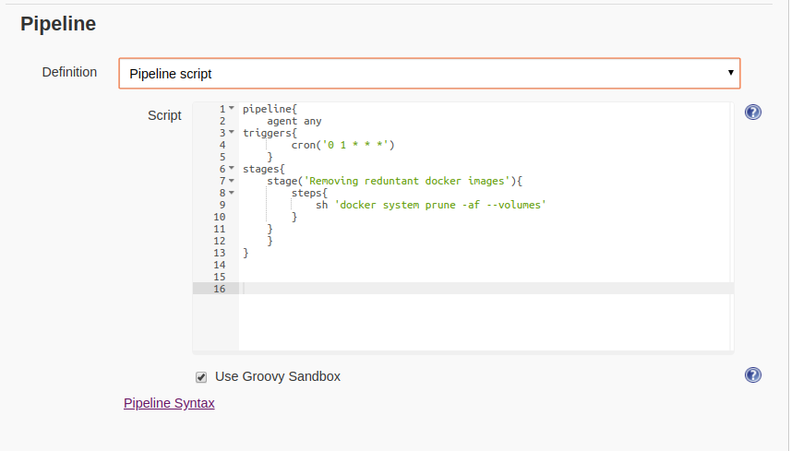

Build the pipeline

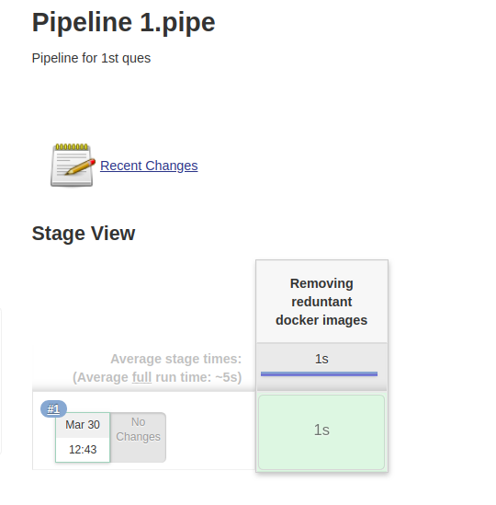

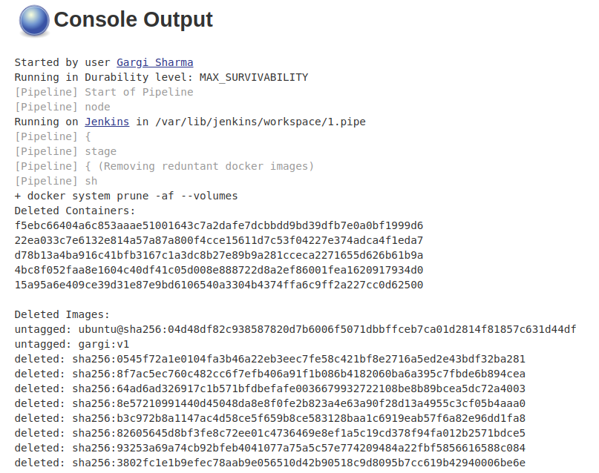

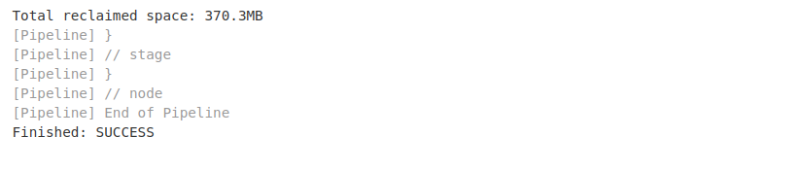

**2. Create a shared library function to convert error and success output into a colorful output and use it in the upcoming questions(Hint: use ANSI color).**

**Create a new repo named ansicolor .**

**Create a similar directory structure for jenkinsfile and groovy script:**

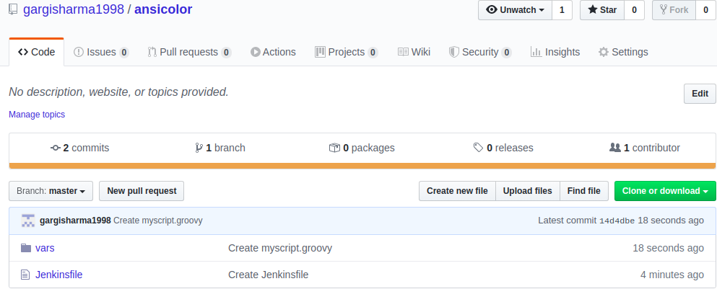

Jenkinsfile:

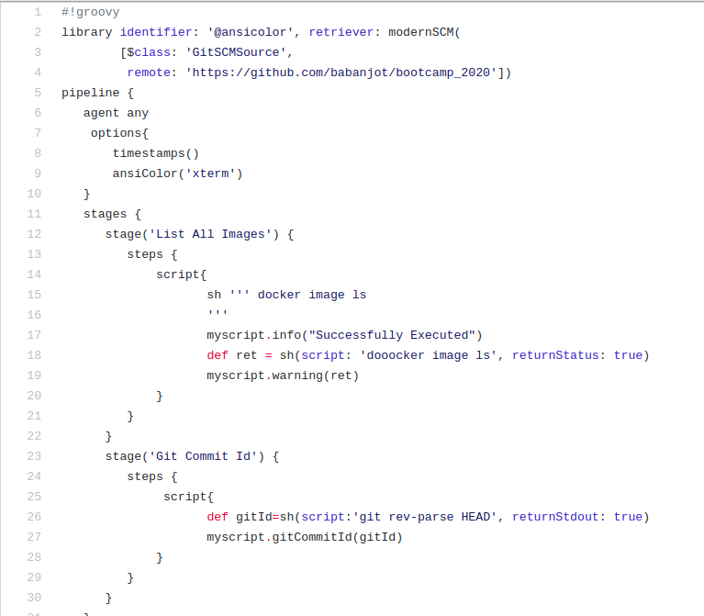

Myscript.groovy:

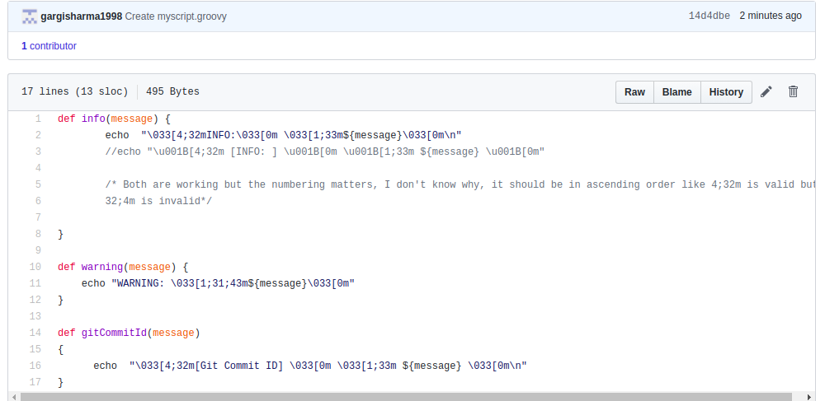

Now go to manage jenkins and download ansicolor plugin:

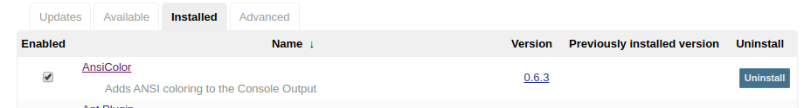

Manage plugins->global pipeline libraries:

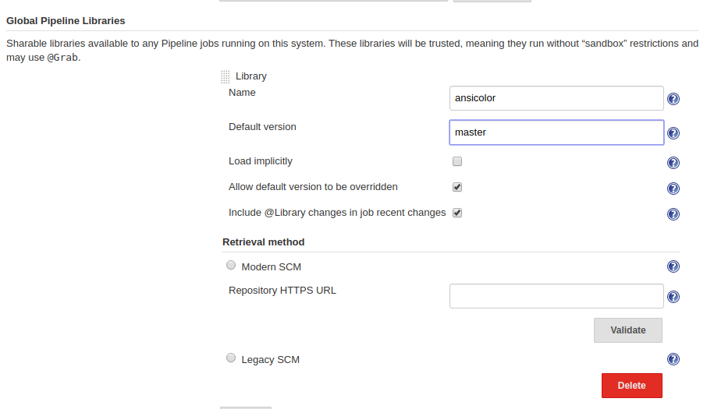

Now create a pipeline job:

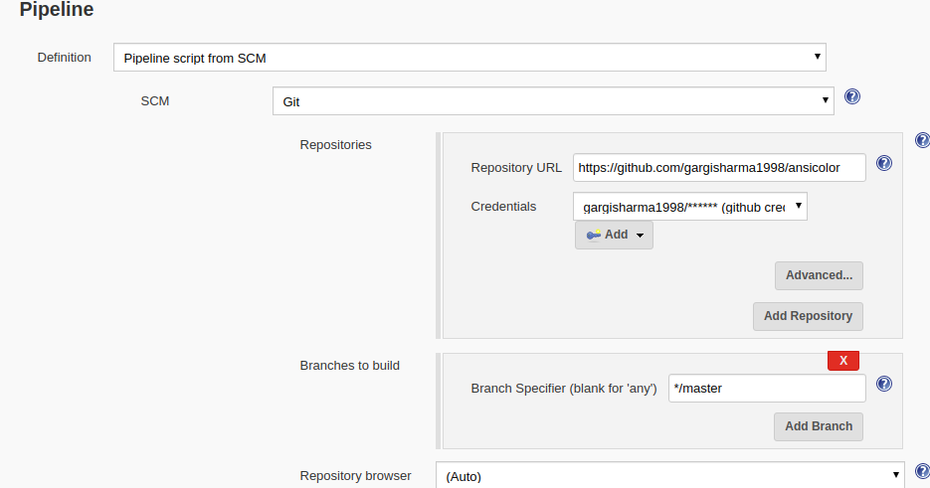

Build the job. Output should be colored:

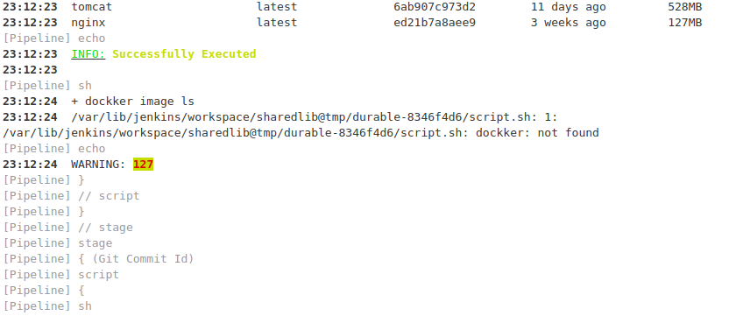

**3. Create a function in the same shared library to output git commitID.**

**Create a groovy script for the following:**

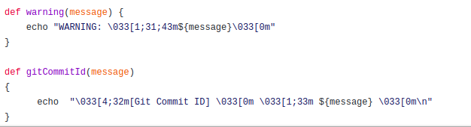

Configure pipeline:



Build the job:

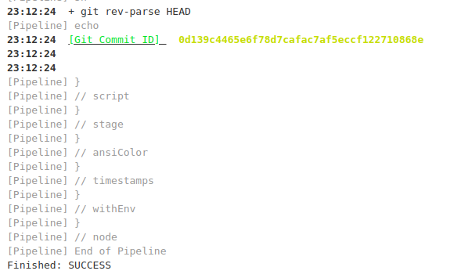

4. **.Take a sample react application and deploy it on EKS**

**a. You can use this repo or any other sample (https://github.com/gothinkster/react-redux-realworld-example-app).**

**b. Create a Dockerfile for react application**

**c. Build and publish image to ECR (create ECR repo of your name) and image must have the git commit id in its name.**

**d. Deploy this image on EKS.**

**e. Send Slack notification/Mail/google chat notification for build pass, abort and fail.**

**Ans: Not enough permissions.**